**SACK FARMING**

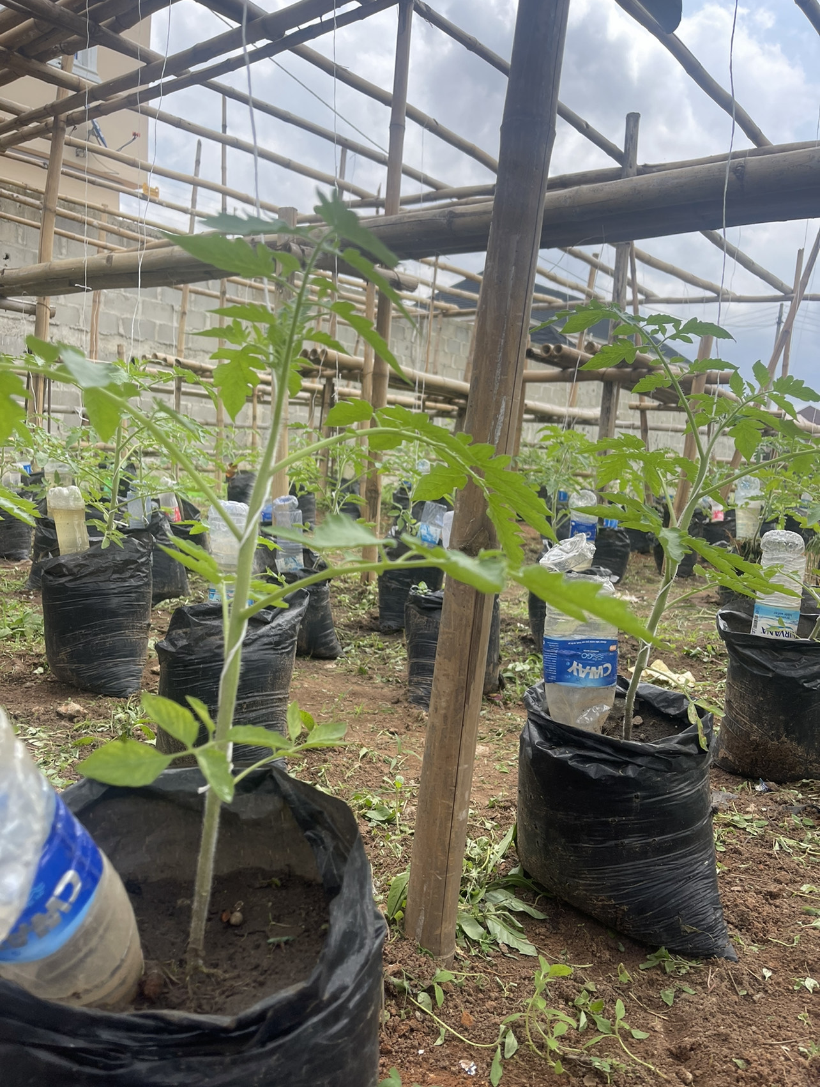

**Lecture 1:**

(Introduction &Requirements)

**Written by**: Toheeb Azeez (The Lasgidi Farmer), Founder Heebgrow

**Contact:** [tohzeez@gmail.com](mailto:tohzeez@gmail.com) +2348062134896

Table of Contents

**Section A3**

About3

**Section B4**

Importance of sack farm4

**Section C5**

Importance of sack farm5

**Section D (Materials Required)6**

Prepare your mind6

Land history and situation8

Soil (type, fertility test, preparation)11

Manure (rich in nitrogen, phosphorus, potassium, and carbon)14

Fertiliser17

Irrigation20

Seeds (hybrid disease resistance)22

Polythene bags (perforated)23

Fungicide (contact & systemic, preventive, protective & curative)25

What do you do with your harvest27

**Section A**

**About**

* Sack farming entails the art of growing food in sacks. Sacks could be of different types (material) -polythene, jute, hemp, etc –quality and sizes.

**Section B**

**Importance of sack farm**

* Helps to innovatively grow food where there seems no arable land.
* Promotes farming where there are little resources.
* Enables efficient food growing by way of conserving space and prudent use of resources.
* Accelerates productivity with optimum use of resources.
* Helps with weed control.

**Section C**

**Crops suitability:**

* Sack farming is suitable for fast growing and short life cycle crops as vegetables and some other arable crops. Not suitable for crops with root that goes deep into the soil and/or that require huge root space. However, it has been successfully/and is being used for growing of tuber crops as yam, although sacks of wider space are used to accommodate growing tuber.

**Section D**

**Materials required**

1. **Prepare your mind**

This is the very first important resource to consider when embarking on this sack farm initiative.

As a beginner who is just trying out such method of production, there is bound to be mistakes, lapses, even failures.

You should understand this from the get-go so you don’t beat yourself up and sabotage when things don’t go according to plan.

You accepting this reality helps with the resilience that enables you continue with the venture should any mishap occur along the way.

However, you should also have the mindset that irrespective of the constraint that may come you would get the approach right.

And one of the crucial ways to get it right is to follow instructions I will be giving (the above inclusive).

They are of my experience from undertaking, failures and success with the innovative production.

1. **Land history and situation**

This is the second crucial factor to consider.

The result you would get from sack-farming your food has a lot to do with the land you’ll be using/location your farm is.

Why this?

First, it has to do with disease and pest problem.

Pests and diseases of plants tend to remain dormant for a long period of time until a host comes by, then they come to live, incubate, become virulent, multiply beyond threshold, going overboard and causing damages that severely impact growth and development of grown crops but also quantity and quality of yield.

Worst is that outbreak and destructions become difficult to control, with subsequent production threatened.

Some lands harbour these pests and diseases either for reason that some cultivation had been done on them in the past where pests and diseases were a problem and hence they hibernate/aestivate in the soil, or that debris or leftovers of plant remains from harvest serve to aid the continuation of their lifecycle.

Examples are white flies that suddenly emerge to infest vegetable crops on a land that hasn’t been worked before or has been left to fallow for a long period or nematodes that attack roots of seedlings.

Another thing is that, the farm or location could just be polluted with wastes as heavy metals, dirt, or excreta of vermin or humans which predisposes plant to risk –directly by injuring plant cells (with toxic elements) or altering pH, impairing growth and development –and enable breeding of unfavourable microbes and pest, respectively.

You want to ensure that you either avoid this kind of land or you take reassuring measures (as solarisation, tidiness, removal of heavy metals by diverse methods, etc) that guarantee protection.

It’s important to note that ensuring a healthy soil and environment isn’t alone for reason of providing conducive surrounding for plants to thrive but also for food safety.

This is because pest capable of affecting humans (for instance, worms with their eggs) or toxic minerals can find their way into growing plants and be residual, which can cause adverse effect to humans on consumption.

Of course you may/will not be planting directly on the ground since sack farm is about planting in sacks and then tend to wonder how land history or situation would constitute a problem.

This is easily understood in that some will excavate soil they need for planting from such land and even when soil isn’t taken from the land, parameters of the land in which sack farm is to be situated could still affect cultivated crops with vectors transmitting diseases.

1. **Soil (type, fertility test, preparation)**

Soil parameters are important for the optimum growth of plants.

Hopefully, as mentioned at the beginning of this manual, you’d be raising fast-growing vegetables. Most of these vegetables –and even for some other crops –require a pH in the range of neutral (7) or somewhat below/above neutral for optimum functioning.

PH influences the availability of nutrients to your plants.

If not in the appropriate range your plants could be starved of vital nutrients or oversupplied one nutrient than the other, detrimental to their health.

Soil fertility has a lot to do with pH, because ph is a product of acidic and basic properties of soil nutrients.

It is why (as said in the previous section) heavy metals can change soil pH directly by elements or indirectly by affecting microbes seeing to important soil reactions that impact pH.

Hence, soil fertility is not only to be ensured but also must be balance.

There are several ways to checking and ascertaining soil fertility status.

This could be traditionally deduced with the type and nature of plants found on the land and soil to be used for production.

If you can see arable crops or your preferred crop growing on it then it could be inferred such soil/land is fit for your purpose.

Also is that some crops grow only where the soil is healthy or you could outrightly tell soil fertility from the vigour of the plants found on it.

However, the downside here is that the plants may have adaptation to soil deficiency or could be affected by something else giving misleading symptoms; or that the soil has been depleted of nutrients but would not be apparent until ensuing use.

Another way to carry out the soil test is by do-it-yourself (DIY) using food materials as baking soda and vinegar (follow [link](https://www.youtube.com/watch?v=BLXJR4HrtHc&t=153s) to learn how to).

The limitation of this method is that you may not get a reaction and have to make assumptions or results may not be accurate to conclude the fertility status of the soil.

But there is a more effective way which entails using soil pH kit test or one could just employ professional test sending soil sample to the lab or have an agronomist do it on site.

While this gives accurate result, it can be costly especially for the latter.

1. **Manure (rich in Nitrogen, Phosphorus, potassium , and carbon)**

In line with the soil fertility discussion above, it is important to make room for nutrient supplements for the soil.

But the type of production one wishes to adopt whether organic or inorganic-led, will determine the supplements to use.

When organic then manure will need to be put in place.

Manure is of different sources –from animal and plant or kitchen waste.

For animal manure there’s of chicken litter, cow dung, rabbit droppings, etc derivatives and the best for vegetables is chicken manure which is rich in nitrogen, phosphorus and potassium.

This also contains calcium, magnesium and some non-essential elements (copper, zinc, iron and manganese) but important for proper plant functioning.

Nitrogen (N), phosphorus (P) and potassium (K) are the basic requirement for and are vital for plant growth and development; hence manure to be considered must have them.

Nitrogen helps with leaf growth and photosynthesis.

Phosphorus ensures root growth and aids catalysing important development (especially flowering) in plant.

Potassium helps in the transportation of nutrients from the soil into the plant and distribution of manufactured food in leaves of plant to parts of plant where they are needed.

Nonetheless, manure that is rich not only in N,P,K but also carbon gives the most benefit, because carbon is the structural backbone of plants –it is in carbon dioxide plants use for photosynthesis; plant cells, organs and tissues are made of it.

Decomposing leaves and plant remains provide needed carbon. Thus, it is recommended to incorporate with animal manure, plant remains.

However, just as it is important to make available manure it is crucial to ensure it is safe for use by curing from pests and diseases and harsh or toxic compounds with thorough composting, as manure can carry or harbour diseases and pests and contain minerals not in their utilisable form.

1. **Fertiliser**

The decision to use fertiliser or manure also is dependent on the pros and cons of each.

Fertiliser, unlike manure, when applied can instantly supply nutrient needs to plant and in an absorbable and utilisable form. Manure would need to degrade over time.

In this way fertiliser can be deployed to rapidly fix nutrient deficiency.

In addition, since exact composition of fertilisers are given or known, you are rest assured quantity of nutrients being supplied to plants.

In agribusiness and commercial production where agriculture is seen as business and with the need for rational production where a known input would generate a certain predetermined output, fertiliser is favoured.

In spite, fertiliser being observed to rapidly accelerate plant growth to harvest without plants reaching expected maturity, impacting firmness and palatability of harvested foods is one demerit people point to.

Nevertheless, manure doesn’t provide just nutrients and hence its slow supply of nutrients cannot be highlighted to discredit its use.

Manure contains humus and organic matter that help enhance water-holding capacity and moisture content of soil and also promote the presence and activities of microbes beneficial to plants.

Could you combine manure and fertiliser together to realise merits of both? Sure! But you want to ensure the nutrients are balance so too much nutrient does burn or kill grown crops.

The last but one advice here when opting for fertiliser is to avoid ammonium-based fertiliser as they tend to stress plants enabling build up of salt within plants which impairs photosynthesis and nutrient uptake.

Ultimate advice in this section when procuring fertiliser, is to get one that has additional nutrients as calcium and magnesium and the non-essential nutrients mentioned.

Calcium and magnesium helps with firm fruit and plant structure reinforcing cell wall from deteriorating to pests and diseases’ attacks.

Copper, zinc, iron, manganese, boron, etc helps with cellular reactions important for various plant functions, development and growth.

1. **Irrigation**

This is another important aspect to consider and water availability for and mode of irrigation is one question one must critically ask self and give proper answer to before commencing production.

Plants, fruit vegetables in particular, even leafy vegetables, require not only water throughout their life, but also constant water and in the required amount.

Too little water causes plant to be weak and predisposed to physiological problems and diseases they would normally be resistant to if they were healthy.

At the other extreme, wet conditions make plant turgid (just as one would be bloated taking too much water) and even waterlogged situation in soil can reduce oxygen availability to the root needed for breaking down of glucose to generate energy in plant’s system.

And the rain can’t be dependent on for irrigation, this is not only for reason that climate has changed for rainfall pattern to be consistent and that it doesn’t make good for production where just a day water unavailability could negatively impact plants.

Water sources as well, dam, borehole, or stagnant water in contours or of rain harvest, are not bad so far they aren’t dirty, smelly, overloaded with chlorides, or do not harbor diseases (remember what was discussed about salt (chloride), and food safety?

Best way to provide water to fruit crops is in small drips.

If you’re able to install drip irrigation, that’s fine but at affordable cost.

If you aren’t and like me would love innovative way to irrigate your plants, but don’t know how to.

Good news! I’ve got an article you can read to establish plastic bottle irrigation , here’s a [write](https://www.linkedin.com/pulse/do-it-yourself-bottle-irrigation-toheeb-azeez-the-lasgidi-farmer-/?trackingId=f3t%2Bez2g5q05wg1l0dUqzQ%3D%3D) up on it and a supporting [video](https://www.youtube.com/watch?v=eQN-mJK32uc).

1. **Seeds (hybrid disease resistance)**

Many of the pests, diseases and environmental challenges one would face with production can be easily solved with growing seeds that have been bred to be resistant to common pests and diseases, and environmental stress or (slight) variations in weather parameters.

You want to make hybrid seeds your ally. Also, these are most times selected for desirable traits that yield in the case of fruits, big, juicy and nutrients and antioxidant-rich.

Avoid as much as possible sourcing seeds from unlicensed dealers or open market; get instead from accredited seed stores/companies or licensed dealers.

When you patronise unverified sellers, not only will you be predisposed to buying seeds that could be adulterated and may not give expected value or returns, you could also introduce pests/diseases to your farm, since seeds, not adequately vetted and treated, could habour pests and diseases.

1. **Polythene bags** (perforated)

For this initiative you need sacks extruded for thickness. The thickness prevents wear and tear and enables use for several production cycles.

Additionally important is polythene sack dimension.

Grow bags in the dimension in inches, 18 by 12, 12 by 15, 20 by 20 all work. They have slight merit over one another.

It is vital to ensure that the bags are perforated to allow for aeration, leaching of nutrients, draining of excess water in the soil so as to prevent poor oxygenation, nutrient toxicity, and wet conditions.

One question I get asked with sacks –and as the name implies –whether it is only polythene bags that can be used for sack-farming, if sacks as leftover cement sacks or something related can be used.

These too can be used. In fact they can hold more quantity of soil and therefore provide bigger growing environment for plants.

One reason I prefer polythene sacs is that they can be made of the same exact dimension, low cost, where same quantity of soil can be filled for all, aiding comparison, projections and analyses across plant stands on equal inputs given.

Another thing is that it aids easy moving around of bags for replacement or operational purposes.

1. **Fungicide (contact & systemic, preventive, protective & curative)**

For those whose production will be chemical-led having in place pesticides and fungicides is nonnegotiable.

Even more important, is arming self with a range of such chemicals that gives protection against the different modes the pests and diseases attack.

Some pests bite and chew plants. Some pierce and suck as would mosquitoes.

Some are active in the day and clearly noticed while feeding on plants. Some are nocturnal and their presence isn’t noticed but only by the destructions or excreta or eggs they leave behind.

Consequently, pesticides that work killing pest when in contact with them may not work for pest you hardly see.

Even, pesticides that leave active residues of active component on plants for pests to consume when they feed on plant surface may not be effective against pests that pierce and suck from cell sap.

Systemic pesticides that infiltrate into plant inner compartment mixing with cell sap are effective for such pests.

In this same way for diseases as fungi disease for instance late blight, which has the tendency to not only affect plants externally but also internally.

Contact fungicides offer preventive and protective effects from the spores from attacking plant surface and mobilising into the plant system or from further attack after initial assault.

Fungicides with active component mancozeb normally would give guaranteed protection against such.

Once inside the plant’s system, preventive or protective fungicides cannot give protection over late blight inside.

What will be needed at this point are curative fungicides that penetrate into plants and kill invading pathogens.

Fungicide having active ingredient copper oxide usually works for this.

1. **What do you do with your harvest**

This question may appear insignificant for a small production or particularly for a first time production.

Rather than just prime your mind for sale of harvest it helps you assume the mindset the production must go well so you can have something to sell even if it would be small.

Moreover, how we do small things is how we do big things. Having dedicated mindset and future thinking in small things would ensure such are translated when big things begin.

Would you consume it? Would you use it to feed your family? Would you sell them to immediate market, for income?

These are all genuine reasons and point of the whole initiative –to ensure individual household security by home-growing foods, and community food security by home-grown foods.